**Application of GIS with Python**

|  |  |
| --- | --- |
| **Submitted By: Prakash Gharti Magar** | **Submitted To: Er. Saurav Gautam** |
| **Class Roll No.: PAS075BGE029** | **Department of Geomatics Engineering** |

**Tribhuvan University**

**Institute of Engineering**

**Pashchimanchal Campus**

**Department of Geomatics Engineering**

**Lamachaur, Pokhara**

1. **Shapefile: what are the different files that constitute a shapefile? Discuss about their importance.**

* A shapefile is an [ESRI](https://www.esri.com/en-us/home) vector data storage format used to store location, shape, spatial index, projection, and attributes of geographic features. It is developed and regulated by ESRI as a mostly open specification for data interoperability among ESRI and other GIS software products. It can describe all features in vector format using point, line, and polygon. The ‘.shp’ file extension alone is incomplete for the distribution of spatial data so shapefile must have at least three file formats like ‘.shp’ for the geometry of feature, ‘.shx’ for an index of geometry, and ‘.dbf’ for attribute data storage of features. It may contain other files with different extension like, ‘.prj’ for projection, ‘.sbn' and ‘.sbx’ for spatial index etc.

1. **Use overpass turbo.eu and download GeoJOSN, GPX and KML file.**

* [**Source Code**](https://drive.google.com/file/d/10C45ZzcV14OuJ54crnX9bVXIgE-NXrbK/view?usp=sharing)**,**
* [**OSM**](https://drive.google.com/file/d/13UvA-mtyG8yM3UqA6YJc1VdahDHx_YNy/view?usp=sharing)**(OpenStreetMap): It is possible to download map data from the OpenStreetMap dataset in a number of ways. The full dataset is available from the OpenStreetMap website download area. It is also possible to select smaller areas to download. Data normally comes in the form of XML formatted .osm files. But, if you want to download entire data of some extent then you need to download .osm file.**
* [**GPX**](https://drive.google.com/file/d/1ADO2jI1qrWyJvkxXDhB5V0RI3LT6qEZk/view?usp=sharing)**(GPS Exchange Format): GPX is an XML file format for storing coordinate data. It can store waypoints, tracks, and routes in a way that is easy to process and convert to other forms. GPX is simply a text file with geographic information such as waypoints, tracks, and routes saved in it.**
* [**KML**](https://drive.google.com/file/d/1ReqOLcd_o52Xzv16Bmmikzh3jhI4wavz/view?usp=sharing)**(Keyhole Markup Language): KML is a file format used to display geographic data in an Earth browser such as Google Earth. You can create KML files to pinpoint locations, add image overlays, and expose rich data in new ways. KML is an international standard maintained by the Open Geospatial Consortium, Inc. (OGC). The KML format was originally developed by Keyhole, Inc. for Keyhole Earth Viewer, a mapping program that was acquired by Google in 2004. The format eventually became a worldwide standard for geographic annotation and visualization in 2D and 3D geographic mapping programs. KML files are primarily associated with the Google Earth web application and Google Earth Pro desktop program. They are also supported by other** **mapping applications, such as Blue Marble Geographics Global Mapper and ESRI ArcGIS Pro.**
* [**GeoJSON**](https://drive.google.com/file/d/1qNZVsLdfMCyzRwRw-NGy70rZ7lHBufjc/view?usp=sharing)**(Geographic JavaScript Object Notation): GeoJSON is an open standard geospatial data interchange format that represents simple geographic features and their nonspatial attributes. Based on JavaScript Object Notation (JSON), GeoJSON is a format for encoding a variety of geographic data structures. GeoJSON supports the following geometry types: Point, LineString, Polygon, MultiPoint, MultiLineString, and MultiPolygon. Geometric objects with additional properties are Feature objects. Sets of features are contained by FeatureCollection objects.**

**GeoJSON Format Data:**

**{**

**"type": "Feature",**

**"geometry": {**

**"type": "Point",**

**"coordinates": [125.6, 10.1]**

**},**

**"properties": {**

**"name": "Dinagat Islands"**

**}**

**}**

/*

This has been generated by the overpass-turbo wizard.

The original search was:

“military=*”

*/

[out:json][timeout:25];

// gather results

(

// query part for: “military=*”

node["military"](25.55235365216549,79.6728515625,30.939924331023445,88.9013671875);

way["military"](25.55235365216549,79.6728515625,30.939924331023445,88.9013671875);

relation["military"](25.55235365216549,79.6728515625,30.939924331023445,88.9013671875);

);

// print results

out body;

>; out skel qt;

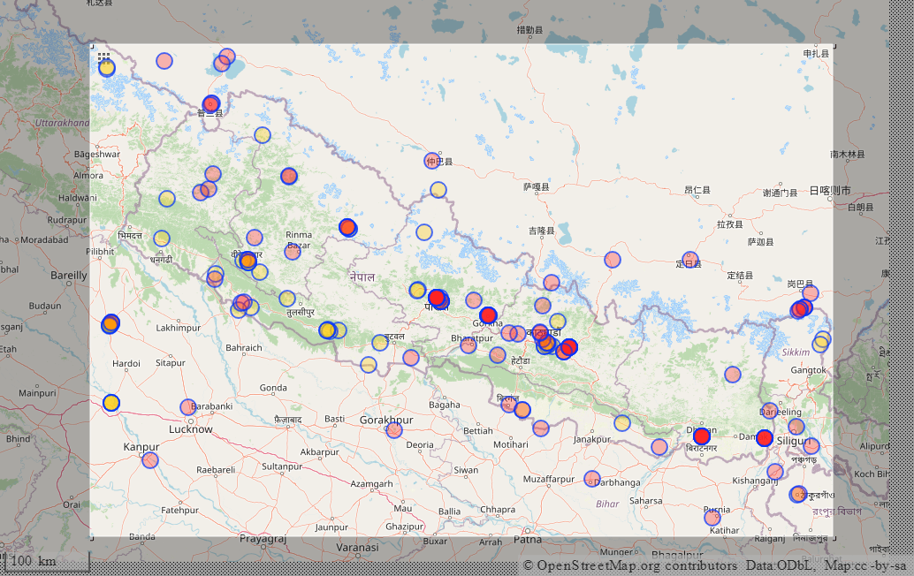

1. **Run the code given in Geoprocessing with python for reading and writing shp. Read the various vector file formats using a text editor and compare between them. (Combined Q3, Q4 and Bonus Q5)**
2. **For Reading Vector Data (ESRI Shapefile)**

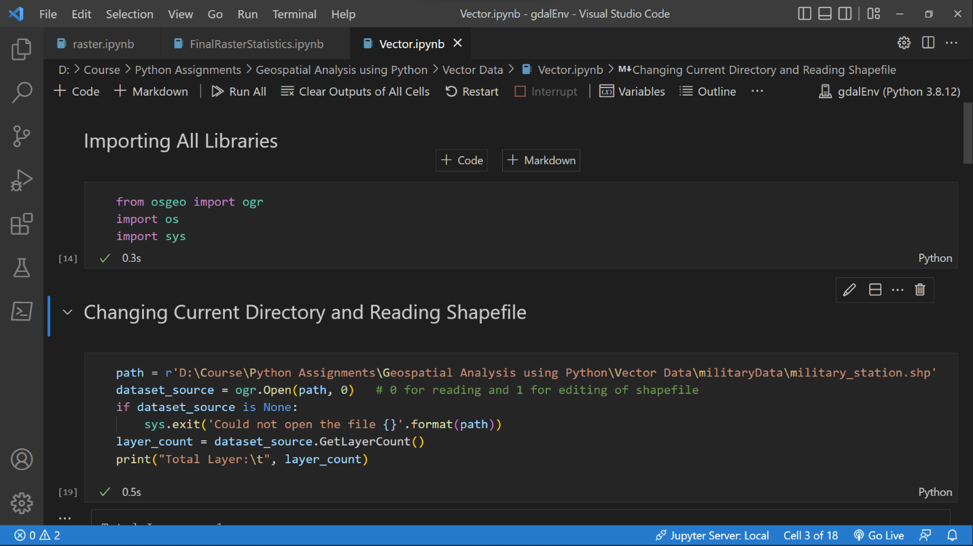

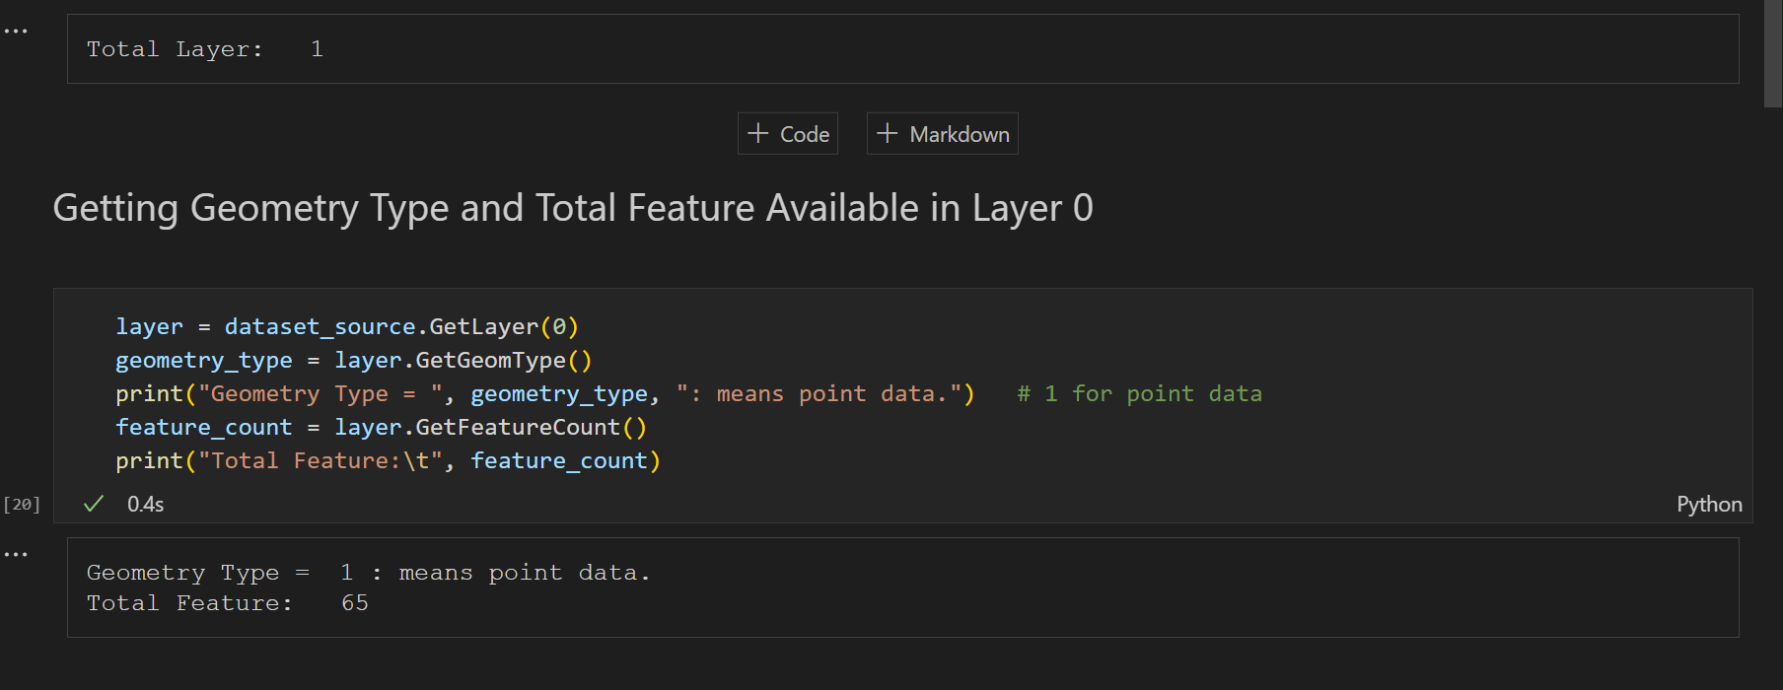

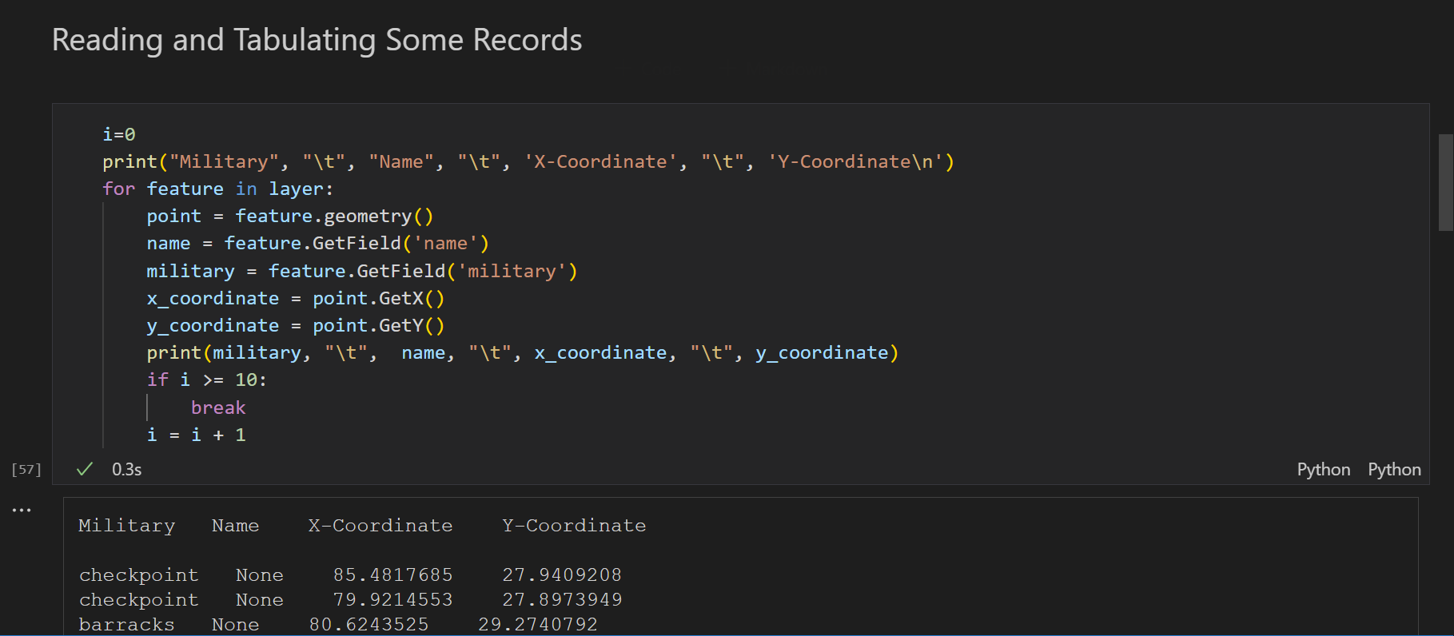

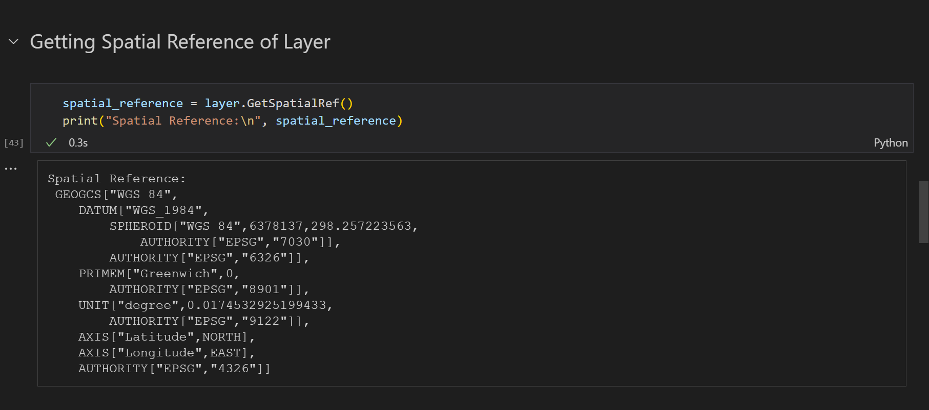

1. **For Writing Vector Data (ESRI Shapefile)**

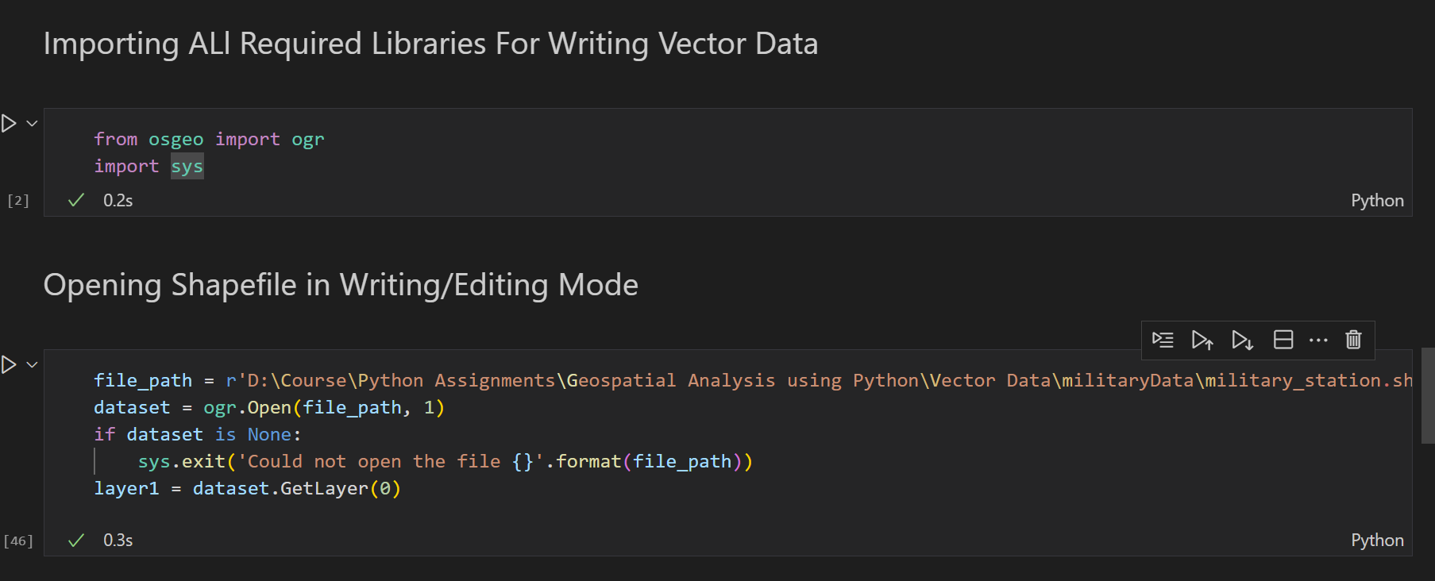

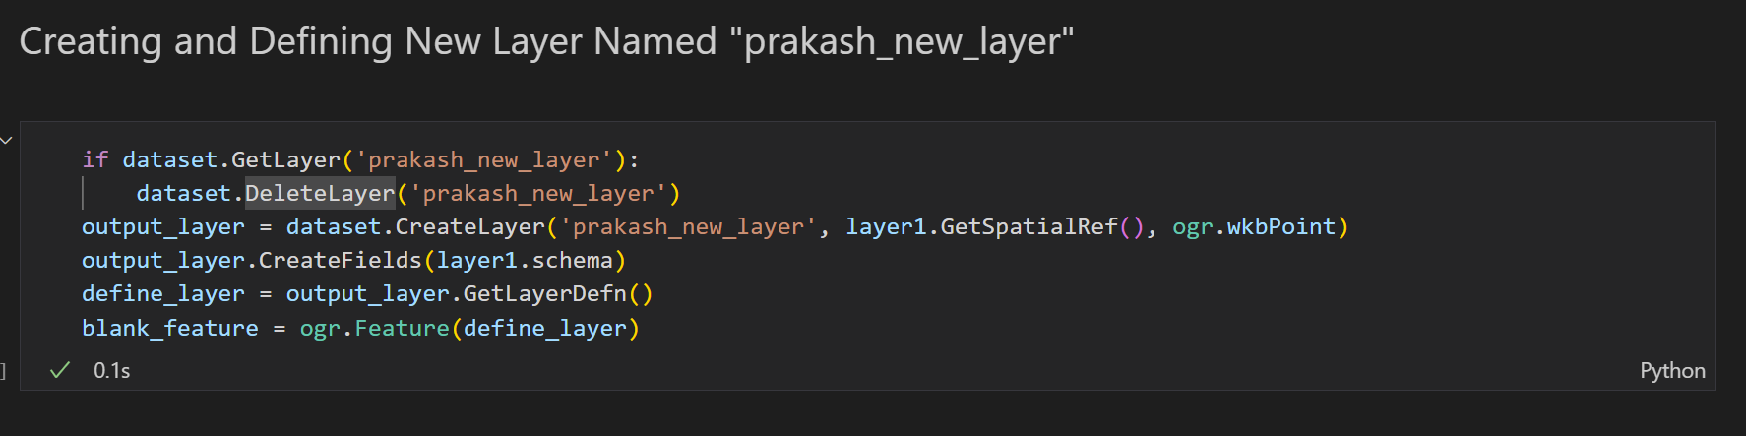

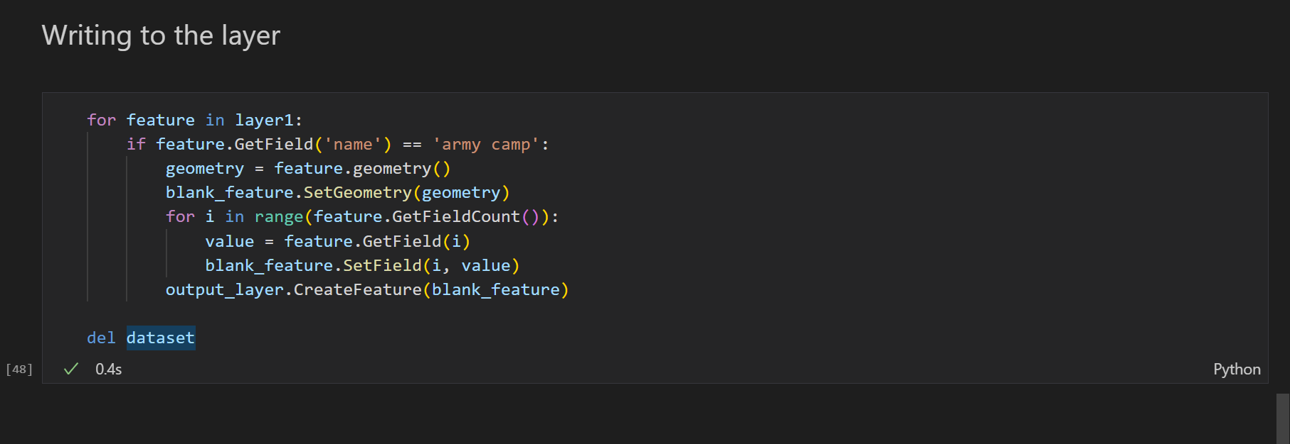

1. **For Reading Vector Data (GeoJSON)**

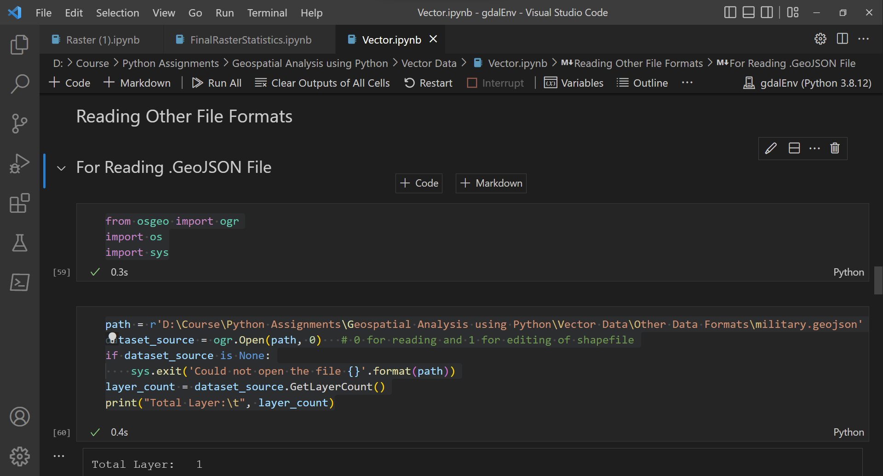

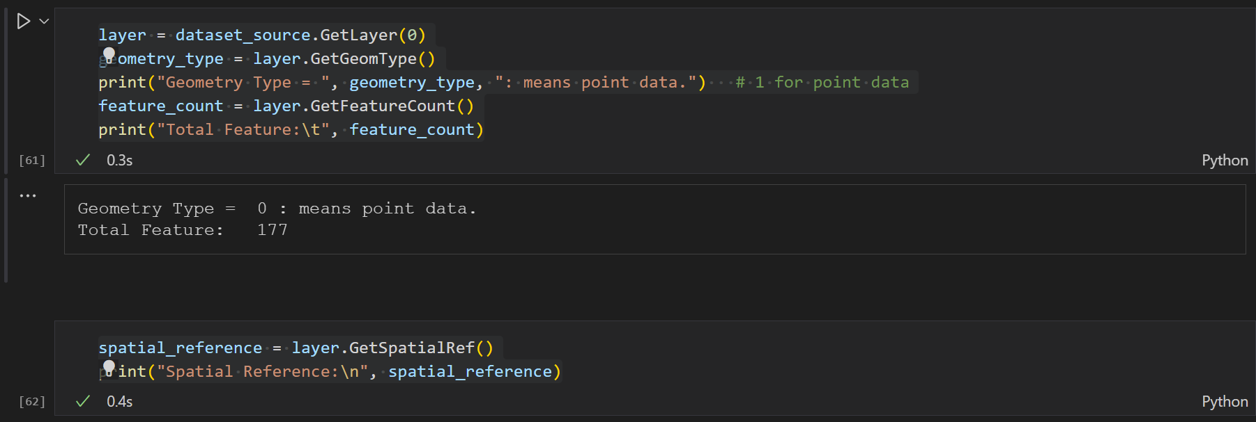

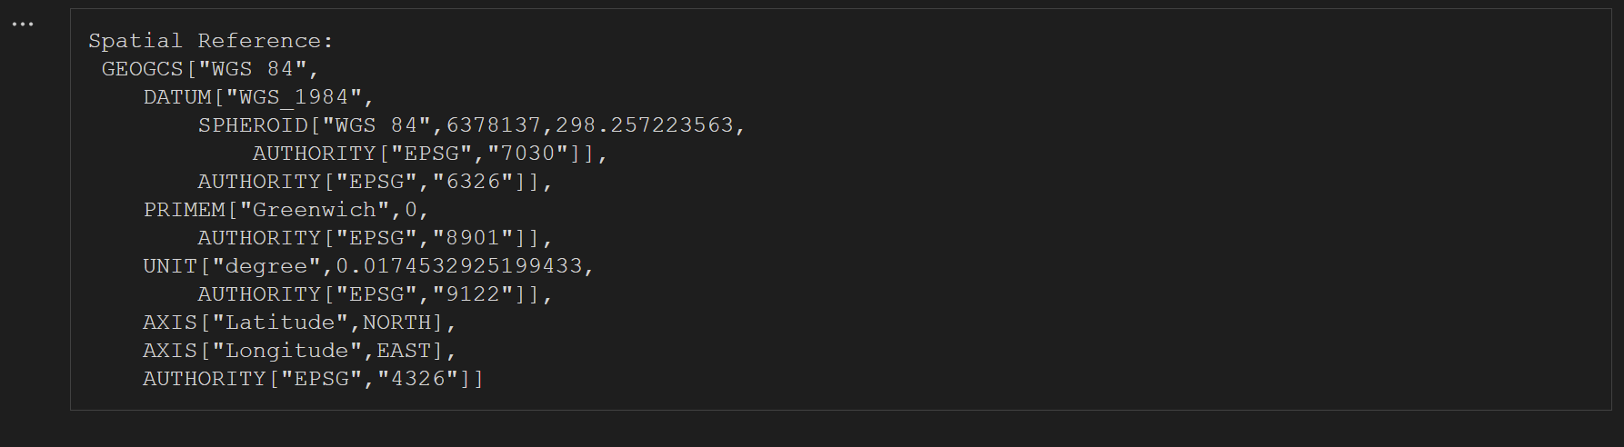

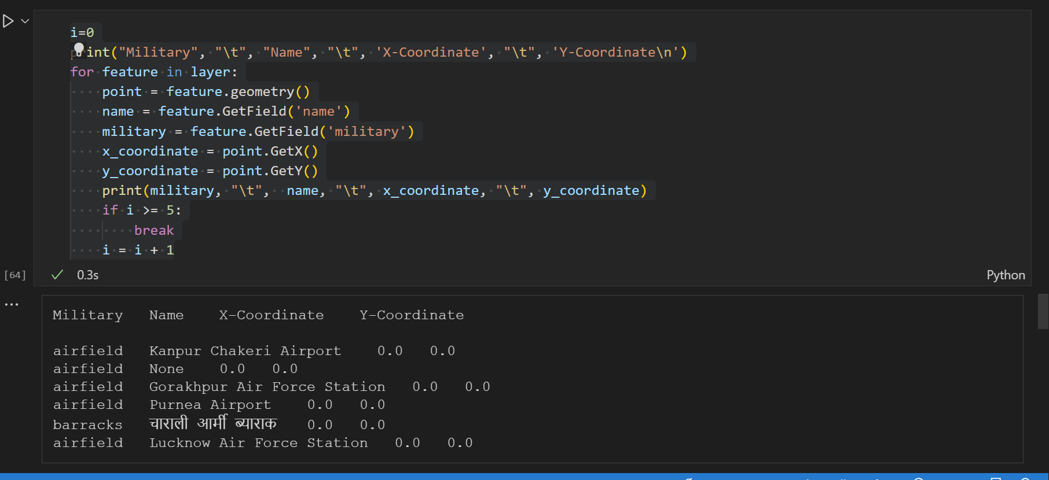

1. **For Reading Vector Data (KML)**

